How to find academic words lists

Log into your account.

Click on Import Lists

Click on Search Other User’s Lists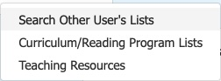

Click Search by List name and type in academic word list


Click Search and view all the different lists. For this lesson, I chose Academic Word list one. So, I will click on Import. Now it is ready for me to use in my account. You can import as many lists as you want into your account. Return to your homepage URL for your students and you will see the new lists that you imported. Now you are ready to share with your students.

