Creating a Google Slide Background

1. **Open** Google Slides. **Give your slide deck a name** such as student introductions **Click insert---Image---Upload from computer.**

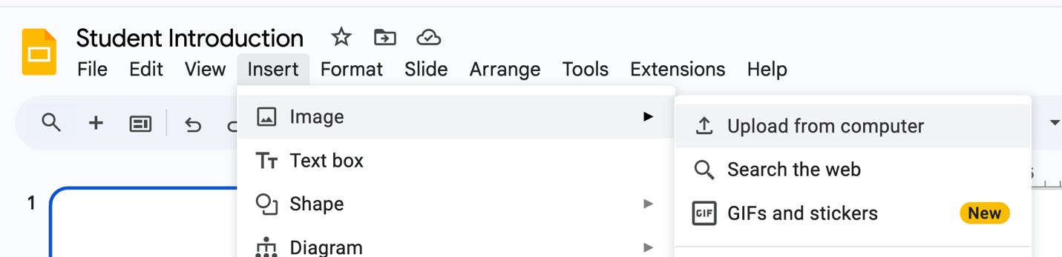

1. Browse your computer to find the image called **Introduction Graphic.**

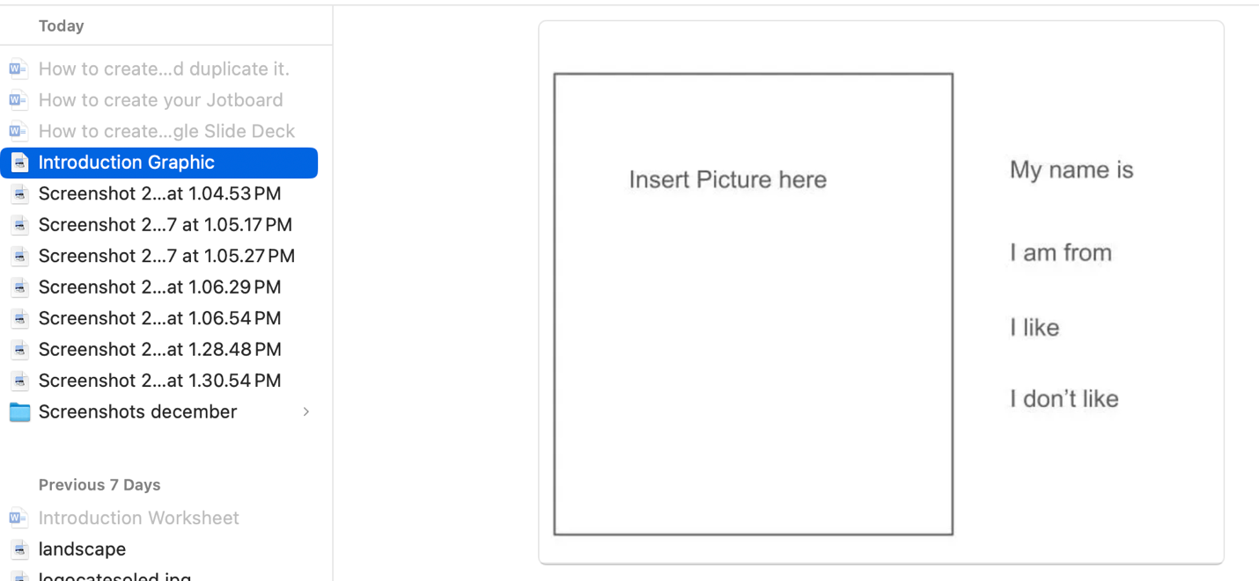

1. Click **Open**
2. **Duplicate the slides by right clicking on the mouse.** so that there is one for every student.

