**How to Use Miro to Create a Mind Map**

1. **Search for a mind map template.**

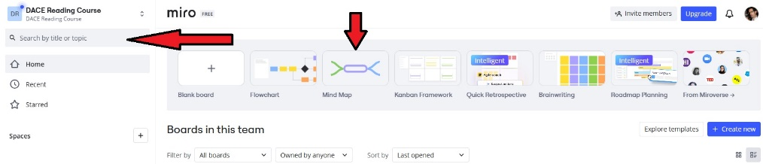

Once signed in, search for 'Mind Map' and click on the 'Mind Map' template button.

A simple mind map board will open which has a main text box in the middle and a few strands emanating outward from the center.

1. **Collaborate**

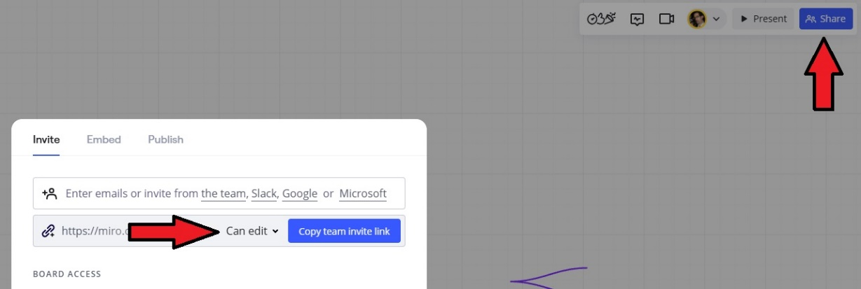

If students want to collaborate, the board can be shared by clicking the blue 'share' button on the top right and entering other students' email addresses. There's also a "copy team invite link" button which you can use to paste the link in a chat (if using Zoom), in your LMS, in an email, etc. Anyone with the link can now collaborate on the board without providing their email address if privacy is a concern.

1. **Title the board**

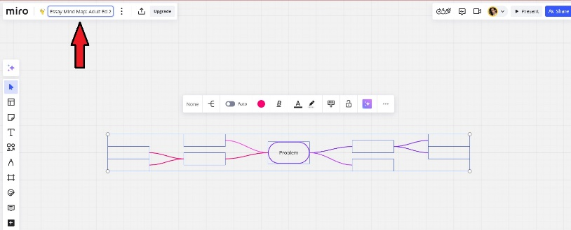

The default title for this board is 'Mind Map'. Simply click on the title to change it to a more personal name, like "Josh's Adult Education Mind Map'.

1. **Create text**

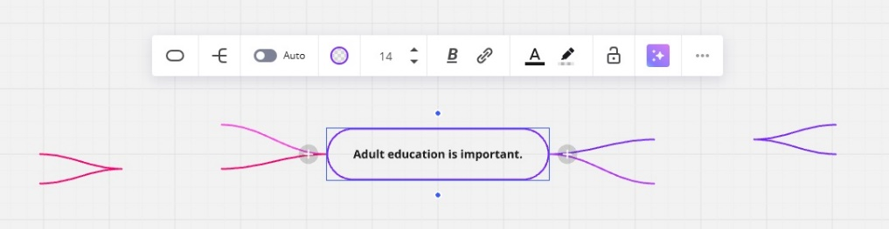

Click on the main text box to write the topic sentence.

1. **Edit a text box**

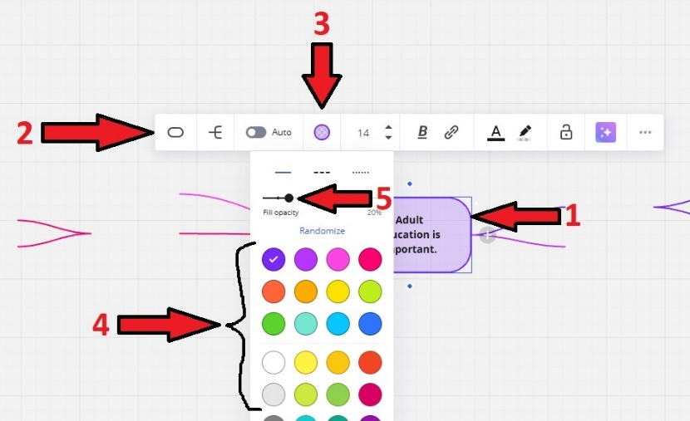

1. Click on the text border edge. You’ll see a double-sided white arrow. Drag to resize the box. You can also drag from the middle of the text box to move it.
2. When you click in a text box, you'll see a simple tool bar with editing tools.
3. Click on the small circle on the tool bar to change the ‘node style’.
4. You can choose a color for the border line and interior of the text box.
5. You can also toggle the ‘fill opacity’ button to change the opacity of the text box fill.
6. **Fill in text boxes at the end of existing strands**

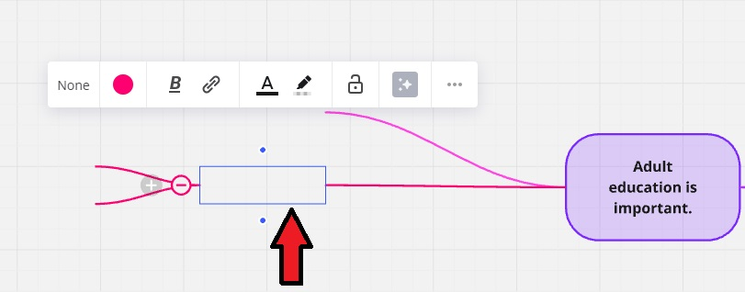

If you click at the end of a strand line, you'll see a text box in which to write a sub-topic sentence. You’ll see a similar tool bar open.

1. **Delete unwanted strands**

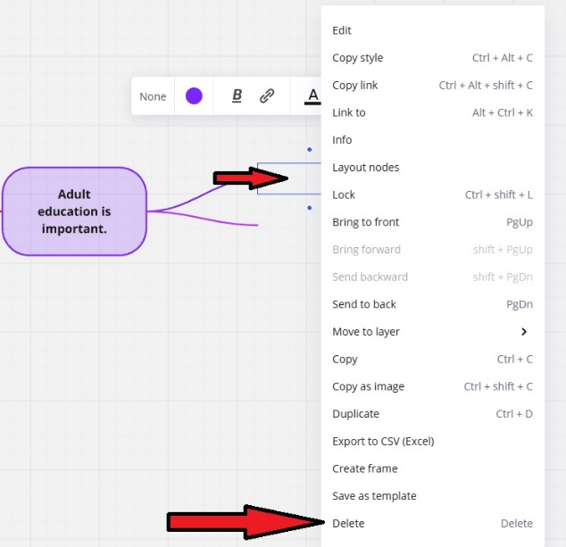

If you wish to delete a strand and its text box, just click in a text box at the end of the strand, right click, click 'delete', and the strand disappears.

1. **Add strands**

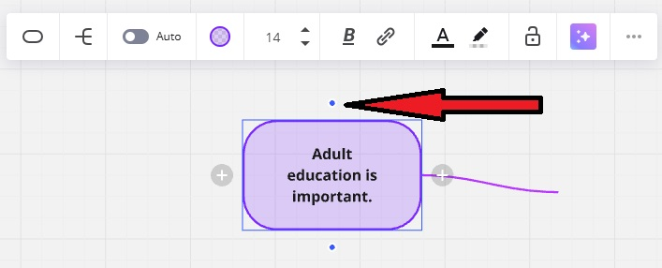

To add a sub-topic strand, click in a text box to open it, then click on a dot next to the text box and drag it. This will create a new strand.

When you let go, it will prompt you with options for the end of the strand. Clicking 'T' will create a text box at the end of the strand. Now, you can write supporting sentences. Also, you can click on the strand line to change the color a opacity of the line.

Text boxes can be dragged to any position. The strand connection will move automatically with the text box.

Repeat the steps to create supporting sentence strands for the sub-topic text boxes.

1. **Share the project**

Once the mind map is finished, there are a few options for sharing the mind map

On the top left, next to the 'upgrade' button, there's an export icon. The board may be saved as a jpeg, a pdf, or a couple of other ways.

You can also share the board as a link directly to the Miro site. Click the blue ‘Share’ button, change the share setting to ‘Anyone with the link’, click ‘Copy board link’, and paste the link to the class LMS, an email, or any other method of your choice.

All screenshot sources: [Miro.com](https://miro.com/)